Auto 0 – Tote and Container.

Start robot positioned at any three locations with Container in arms, and elevator down.

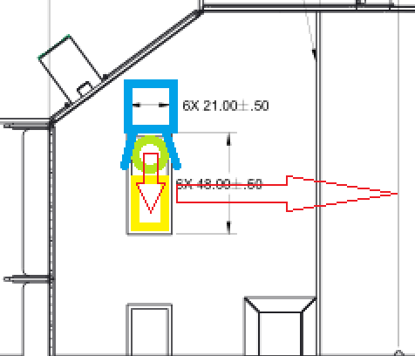

Auto 1 = Drive Straight from Starting

Start anywhere centerline of the bot, approximately equal to the centerline of the totes in staging area.

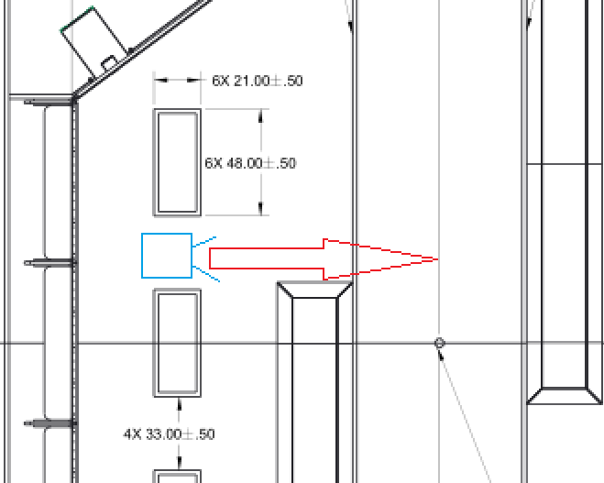

Auto 2 = Drive straight from Voldermont

Start anywhere in Voldermont Zone (The Zone that cannot be named), back close to edge of totes in landfill.

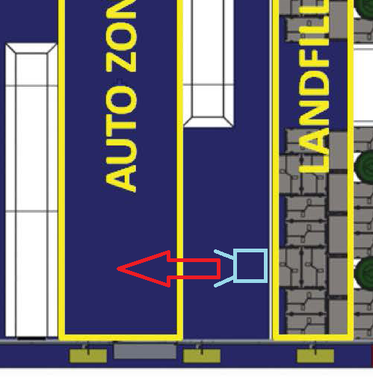

Auto 3 = 2 Container Left Turn

Start with totes off field, bot with container in arms, two locations possible.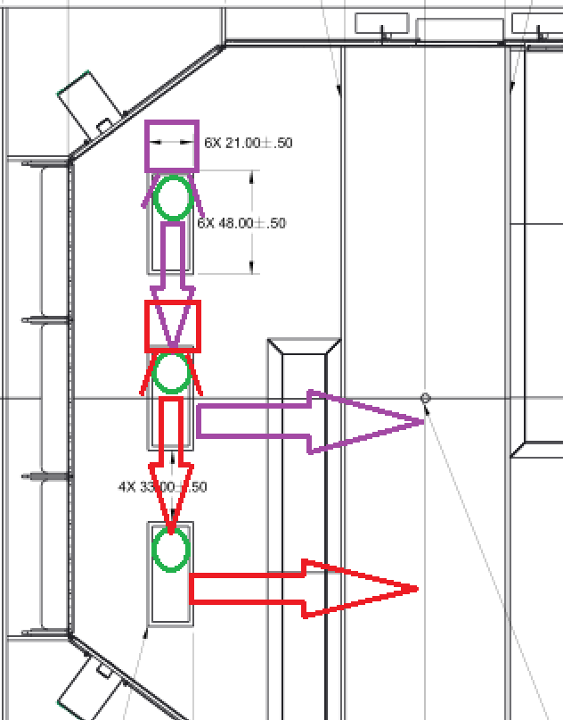

Auto 4 = 2 Container Right Turn

Start with Totes off field, bot with container in arms, two locations possible, where totes usually sit.

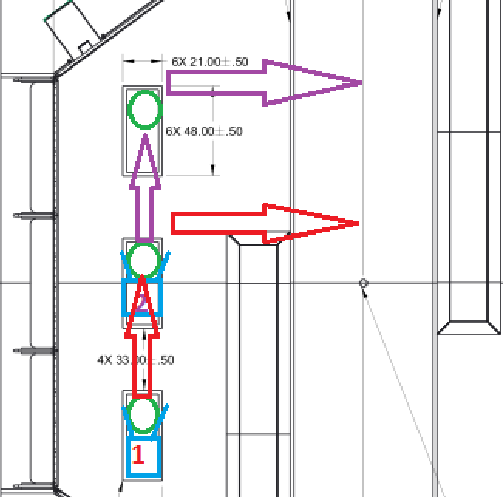

Auto 5 = Do Nothing.

Start anywhere, stays where set.